**Project Status Update: Automated Backup and Restoration with PowerShell**

Currently, the project is in the implementation phase, with initial research and planning completed. The scripting process has begun, focusing on automating backups for critical files, system states, and virtual machines using PowerShell. Additionally, a logging mechanism is being developed to monitor the backup and restoration process for troubleshooting and auditing purposes.

The primary objectives of this project are:

* **Automate backup processes** for system-critical files and virtual environments.
* **Validate the restoration process** in a virtualized environment to ensure reliability.
* **Implement logging mechanisms** to track all backup and restore operations.
* **Ensure security and efficiency** in backup storage and retrieval.

**Gantt Chart Proposal**

|  |  |  |  |
| --- | --- | --- | --- |
| **Week** | **Date Range** | **Task** | **Status** |
| **Week 1** | Jan 6 - Jan 12 | Research and define project scope | ✅ Completed |
| **Week 2** | Jan 13 - Jan 19 | Identify tools and technologies (PowerShell, Hyper-V, Task Scheduler, etc.) | ✅ Completed |
| **Week 3** | Jan 20 - Jan 26 | Draft initial PowerShell script for file and system state backup | ✅ Completed |
| **Week 4** | Jan 27 - Feb 2 | Develop logging mechanism for tracking backup status | ✅ Completed |
| **Week 5** | Feb 3 - Feb 9 | Implement and test backup script for Hyper-V virtual machines | 🔄 In Progress |
| **Week 6** | Feb 10 - Feb 16 | Develop restoration script and integrate with logging system | 🔲 Upcoming |
| **Week 7** | Feb 17 - Feb 23 | Test full backup & restore cycle in virtual environment | 🔲 Upcoming |
| **Week 8** | Feb 24 - Mar 2 | Troubleshoot issues and optimize automation workflow | 🔲 Upcoming |
| **Week 9** | Mar 3 - Mar 9 | Final testing, debugging, and performance evaluation | 🔲 Upcoming |
| **Week 10** | Mar 10 - Mar 16 | Documentation and final report preparation | 🔲 Upcoming |
| **Week 11** | Mar 17 - Mar 23 | Project submission and presentation | 🔲 Upcoming |

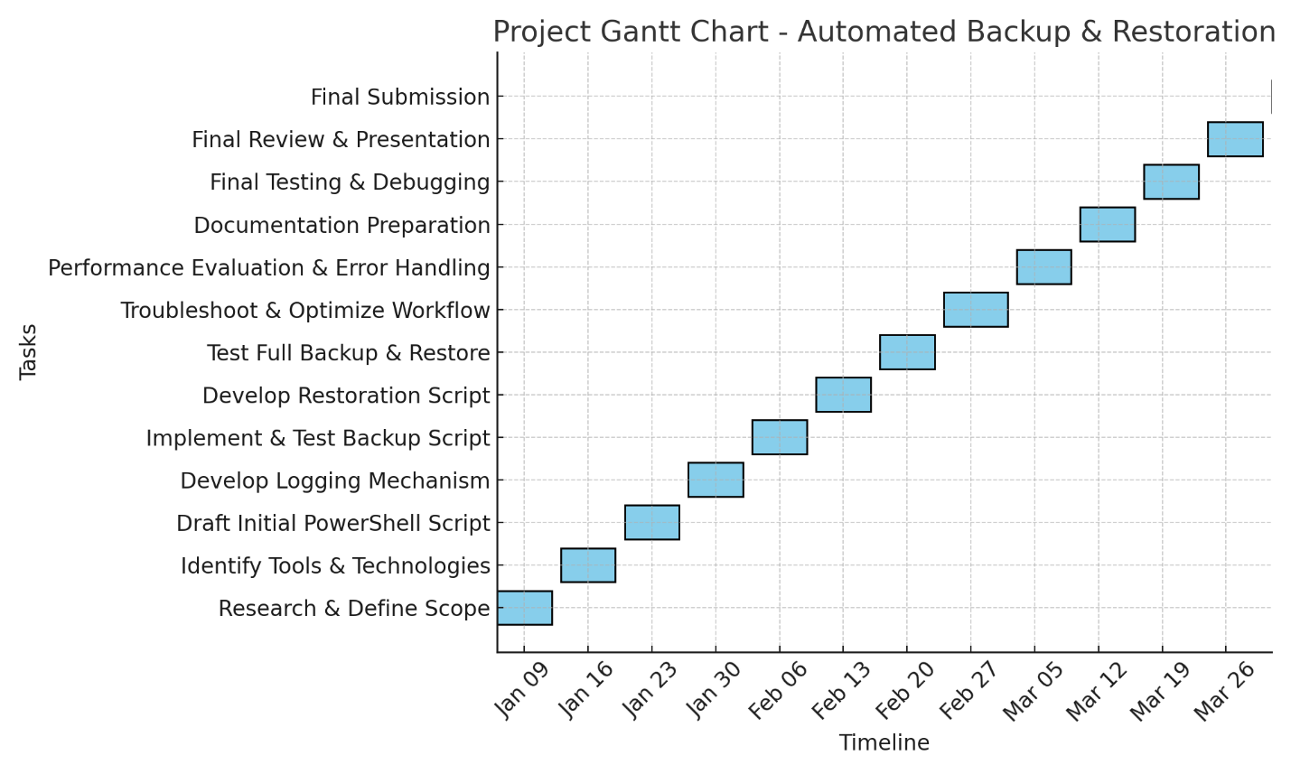

**Foreseen Challenges and Issues**

Several difficulties are foreseen for the subsequently parts of the project:

* **Permission Issues**: System state and Hyper-V backups may require elevated privileges, and this may result in automation problems.
* **Storage Considerations**: Maintaining various backup copies without incurring unreasonable disk space costs.
* **Backup Error Management**: Proper management of Backup processes' failure notifications and logs for prompt action.
* **Testing Restoration Scenarios**: Checking restored files/system states in different failure scenarios to determine their accuracy and completeness.
* **Automated Scheduling & Performance**: Adjusting script run time to not negatively impact the status of active environments.

These activities will shift focus toward the further polishing of the whole automated workflow along with the restoration script as well as useful logging integration. The project is on track to be completed within the planned timeline.